Category 5e Unshielded Keystone Jack

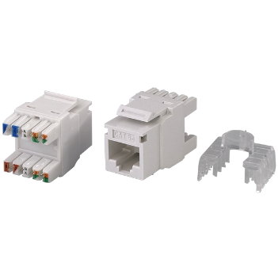

Category 5e keystone jack is designed for superior performance that meets or exceeds industry standard ANSI/TIA-568.2-D and ISO/IEC 11801 2nd edition requirements. The keystone jack will balance signal transmission of insertion loss and crosstalk from 1 to 100 MHz. Jacks are available in 9 colors to match housing or allow color coded designation port in compliance with TIA-606 requirements.

Features

Contacts are phosphor bronze plated with 50 micro inches hard gold

Option for KRONE/110 Universal IDC connector or tool-free type

Supplied with plastic strain relief cap for IDC connectors

Large selection of colors, provides many options of color coded designation port

Polycarbonate 94V0 rated

UL Listed

Itertek ETL / Force EC Cat.6A VERIFIED

4PPoE compliant in accordance with IEEE802.bt Type 4

Ordering Information

|  |  |
| --- | --- |
| PART | Description |
| 0A58RP0e0-XX | RJ45, 8-Conductor Cat.5e, KRONE/110 IDC, Unshielded, 180 degree, H.D. version, fits 0.5U panel |
| 1A58TP0e0-XX | RJ45, 8-Conductor Cat.5e, Tool-free, Unshielded, 180 degree, H.D. version |
| 1K58KP0e0-XX | RJ45, 8-Conductor Cat.5e, KRONE/110 IDC, Unshielded, 90 degree, H.D. version |
| 2K58TP0e0-XX | RJ45, 8-Conductor Cat.5e, KRONE/110 IDC, Unshielded, 90 degree, Short depth design, L=28.8mm |
| 0T58TP0e0-XX | RJ45, 8-Conductor Cat.5e, Tool-free, Unshielded, 90 degree, H.D. version |

“XX” = color choices – ivory (IV), white (WH), gray (GY), black (BK), red (RD), orange (OR), blue (BL), green (GN), yellow (YL)